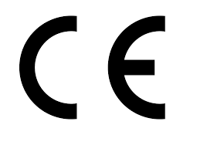 | Schnittschutzhandschuh W-110 Level B  Cut protection glove W-110 Level B
0899400739; 0899400740; 0899400741; 0899400742; 0899400743
This product is identical with the PPE for which
Satra Technology Europe Ltd
Bracetown Business Park
Clonee, Dublin, D15 YN2P
Ireland
Notified Body 2777
issued the following EU type examination certificate:
2777/10208-03/E05-01
This product is subject to the conformity assessment procedure of module:
B
We declare under our sole responsibility that this product conforms with the following harmonised norms:
EN ISO 21420:2020; EN:388:2016+A1:2018
according to the provisions of Regulation (EU) 2016/425
Adolf Würth GmbH & Co. KG  Reinhold-Würth-Straße 12 - 17  74653 Künzelsau  GERMANY | $SIGNATURE_36 | $SIGNATURE_37
Künzelsau, 2023-07-12 | Frank Wolpert  Prokurist - Leiter Produktmanagement  Head of product management,  Authorized Signatory | Dr.-Ing. Siegfried Beichter  Prokurist - Leiter Qualität  Head of Quality,  Authorized Signatory

